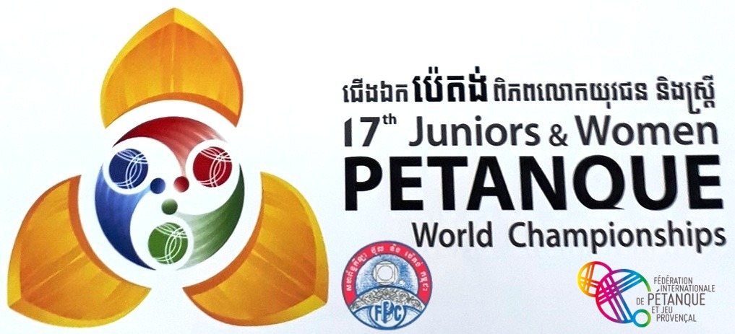
WORLD CHAMPIONSHIPS PHNOM PENH: SIMULTANEOUS PROGRAM

Monday 18th : Arrival of the teams - Home

Tuesday 19th :

8:30 am - 12.00: International Congress and draw

2 pm: Opening Ceremony

3:30 pm: Youth and Women's Precision shooting : Qualifications first round

Meal

Wednesday 20th :

8 am: Youth and Women's Precision shooting : Qualifications second round

9:30 am Youth first round

11:00 am Women's first round

Youngsters eat

11.30am / 2pm meals

12.30 Youth second round

Women eat

2 pm Women's second round

3:30 pm Youth third round

5 pm Women's third round

Meal

8 pm Presidents' meal: 2 people per country and FIPJP board

Thursday 21st:

8 am Youth fourth round

9:30 am Women's fourth round

11:00 am Youth fifth round Young

Women eat

11.30 am / 2 pm meals

12:30 Women's fifth round

Youth eat

2 pm Youth and Women's Nations Cups : cadrages
Women's WCS : first round to bring back from 24 to 16

3:30 pm Youth : eighths WCS and Nations Cup (or 1/16e)

5 pm Women : eighths WCS and Nations Cup
(Possibly) Youth : eighths of Nations Cup

Meal

Friday 22nd:

8 am Precision shooting : Youth Quarterfinals

9 am Precision shooting : Women Quarterfinal

10 am Precision shooting : Youth Semifinals

10:45 am Precision shooting : Women Semifinal

11:30 am Precision shooting : Youth Final

Meal

1:30 pm Precision shooting : Women Final

2 pm Precision shooting Youth and Women Podiums

2:45 pm Youth : quarterfinals WCS and Nations Cup
Women eighths Nations Cup

4:15 pm Women quarterfinals WCS and Nations Cup

Meal

Saturday 23d :

8 am Youth : Semifinals WCS and Nations Cup

9:30 am Women : Semifinals WCS and Nations Cup

11 am Youth and Women's : Nations Cup Finals

11.30 am / 2 pm : Meals

2 pm Youth : Final

3:30 pm Women : Final

5 pm Youth and Women : Podiums

6:30 pm: Closing evening with trophies (National Clothings: players who will not wear them will not be allowed to climb onto the podium)

Sunday 24th: Departure of the delegations

NOTES: Qualifying rounds of the world championships in 1 hour plus two ends if necessary. Nations Cups: Games in time limit until the semifinals.

This program may be modified according to the course of the competitions and the number of participating teams, in particular with the passing of the losers in the eighths of WCS to the eighths of Nations Cup.

