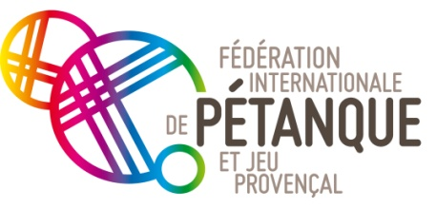
Fédération Internationale de Pétanque et Jeu Provençal
Siège Social : 13, rue Trigance – 13002 Marseille (France)
Tél. : (33) 4 91 14 05 80
E-mail : fipjp@fipjp.com

Paris on August 23d, 2019

Madam, Mr. President,

It seems some federations didn't receive or badly received the information and requests for reservations from the Federation of Cambodia. So we send you again these information and put them on the FIPJP website.

Your federation is therefore invited to participate in the 17th World Championships of Women and Youth, which will take place in Phnom Penh - Olympic Stadium - from November 19th to 23d.

An official greeting will be organised at the airport and shuttles will drive you to your hotel. The distance is about 10 kilometers

In accordance with the specifications of the World Championships, the Federation of Cambodia will take charge of:

- 4 people per team - Women or Youth - for 6 nights with breakfasts in double rooms (from Monday evening to Sunday morning), 10 meals and closing gala on Saturday evening 23d, with free admission to the competition site

- Entrance to the competition site for the head of delegation and coaches (one per team)

- The head of delegation or his representative for the presidents dinner on Wednesday evening 20th

The International Congress will be held on Tuesday 19th at 8:30 am in the conference room of the Olympia Hotel. For federations wishing to attend it without participating in competitions, the Federation of Cambodia will take charge of the two nights of Monday evening and Tuesday evening, as well as 3 meals for one person.

They have to send a reservation to the organising committee.

For members of your delegation not taken in charge and for additional days of people taken in charge, the prices will be:

* In single:

- USD 90 per day with breakfasts and meals included

- USD 60 per day with breakfasts but without meals

* In double rooms (Twin or double bed)

- USD 65 per person per day with breakfast and meals included

- USD 35 per person per day with breakfast but without meals

* Closing meal:

- 17 USD for other persons than 4 players per team, coach and head of delegation taken in charge

* Also think of the admission tickets whose rates will be communicated to you by the organizers

The deadline for returning the booking form is SEPTEMBER 15th

On behalf of the Cambodian Boule and Pétanque Federation, which will be very honored to receive your delegation in Phnom Penh, we warmly welcome you into the capital of Cambodia.

Cordially

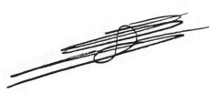

Claude AZEMA
FIPJP President

