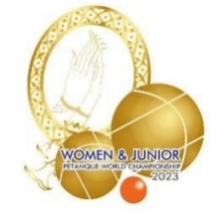
The 19th Women and Junior
World Championship 2023
Bangkok, Thailand

Federation:
The Photo of Junior Athletes
Player | Surname | Name | Photo
1.
2.
3.
4.
* Please fill your surnames and names in the 2nd and 3rd column, respectively. Then copy your photo and paste it in the last column.

The 19th Women and Junior
World Championship 2023
Bangkok, Thailand

Federation:
The Photo of Women Athletes
Player | Surname | Name | Photo
1.
2.
3.
4.
* Please fill your surnames and names in the 2nd and 3rd column, respectively. Then copy your photo and paste it in the last column.

The 19th Women and Junior
World Championship 2023
Bangkok, Thailand

Federation:
The Photo of Coaches
Player | Surname | Name | Photo
1.
2.
3.
4.
* Please fill your surnames and names in the 2nd and 3rd column, respectively. Then copy your photo and paste it in the last column.

The 19th Women and Junior
World Championship 2023
Bangkok, Thailand

Federation:
The Photo of Head of Delegations
Player | Surname | Name | Photo
1.
2.
3.
4.
* Please fill your surnames and names in the 2nd and 3rd column, respectively. Then copy your photo and paste it in the last column.

